Your guide to HYCS’ telephone and
online (video) counselling services
A new way of working – telephone and
online (video) appointments
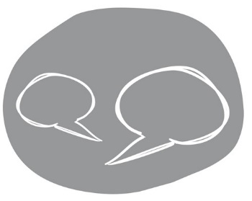
Hounslow Youth Counselling Service (HYCS) has changed the way it is now delivering 1-2-1
counselling support to young people because of the COVID 19 pandemic and ongoing lockdown
restrictions. The service has largely moved from face to face counselling sessions to telephone or online video appointments.
The information in our “HYCS Introduction Booklet” explains how we
approach counselling generally and this still applies but there are also some changes which we will explain in this leaflet, and to which we need your agreement, in order to offer you online/telephone support.
• Existing clients - your counsellor will ask if you want to switch to telephone/online
counselling during the Covid-19 restrictions or if you prefer to wait for face to face work to resume.
• New clients - Age 13+ - you will be offered the option of either telephone or online
counselling at this time. Alternatively you can wait until face to face sessions are available.
Ages 11-12 - this age group can only currently be offered face to face work, subject to
availability.
Is telephone or online (video) counselling right for you?
Having counselling online via a video link or on the phone can feel very different to face-to-face so it's important that you have thought about the pros and cons for you and your particular home
situation. Have a think and let us know what feels right for you or if you want to talk anything through.
- Advantages? It can be a very accessible, efficient and flexible way of getting
support allowing you to access support from your own home or at a place/time that really suits you.
- Disadvantages? Not everyone is comfortable using technology or talking on the phone. There can be some technical disruptions and data security cannot always be
guaranteed online; it may simply be tricky to find a quiet, private space to talk or to gain access to a phone or computer.
Understanding & consenting to the service we can offer
It is important that you understand the nature of the service we can offer you so please read all of the information in this leaflet and then confirm you are happy to go ahead when you speak to the HYCS counsellor – if you have any questions please just ask.
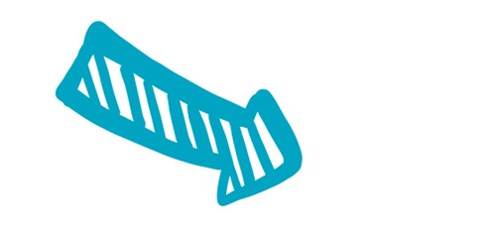
Confidentiality – The work we do together is confidential unless in some circumstances where we have a concern for your safety or the safety of others and then we may need to talk to other professionals to get support. We will always aim to discuss this with you first. If you attend any face-to-face sessions, please note we also comply with Test and Trace requirements in the public interest. HYCS will take all reasonable measures to ensure your privacy but please be aware that digital systems are not always 100% secure. In addition you will also need to ensure privacy at your end, making sure that you have a safe, private space at home in which to talk and where you cannot be overheard.
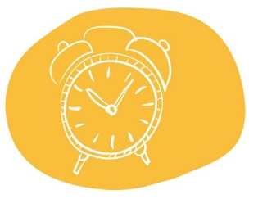
Recording privacy - HYCS does not allow the audio or video recording of any client
session either by the counsellor or by our clients.
Safeguarding & Safety – If the counsellor has serious concerns about your safety or that of
others they will aim to discuss this with you and also with the HYCS’ manager with responsibility for safeguarding. They will work in your best interests and keep you informed if they need to report their concerns to appropriate professionals to keep you safe.
As part of our ongoing commitment to your safety, at the start of every session, the counsellor will also ask you to confirm your current location and to nominate an emergency contact/contact
number.
How would you like us to communicate with you? – Your counsellor will agree with you what method of contact works best for you, both for the counselling session itself and in setting up sessions or to get a message to you if
connection is lost.
Appointment time - You can agree with your counsellor the day/time for contact each week. Be aware it may be hard to always commit to a
regular time slot so you both may need to be flexible and communicate any difficulties.
For telephone calls - the counsellor will call you on the number you have given us at the agreed time. For video calls - the counsellor will send a link for you to use at the agreed time.
Length of session – Sessions will normally be for up to 50 minutes.

Technical Problems - Technical issues may arise from time to time, for
example due to poor connection or signal. If you/your counsellor experience technical difficulties, the counsellor will try to make contact with you for a further 10 minutes.
The counsellor may also try contacting you via your additional contact details if they have your agreement to do so should you get cut off or they are unable to reach you at the appointment time.

Cancellations / illness / changes in circumstances
If you need to contact your counsellor to rearrange/cancel a session please contact the HYCS office - please give your name, counsellor’s name and the date of your session if leaving a message. HYCS: tel. 020 8568 1818, text 07784 481308 or email ask@hycscounselling.co.uk.
Missing sessions - If you missed a session and we have not heard from you to let us know (before or afterwards) then we will assume that you no longer want counselling. You will need to contact us to re-register.
Ending a session early – If you need to end a session early or suddenly,
perhaps for example because you find you are no longer in a private space at home, if you can please let your counsellor know or inform them when you are safely able to do so by text/email to the HYCS office.
Counsellor’s right to end a session – If there is interruption due to other people being present in the room or inappropriate dress code or behaviour from the client or the setting itself
appears unsafe, the counsellor reserves the right to end the session and reschedule if needed. The counsellor will let you know if this is the case.
Reviews and Ending sessions
You can review your work with your counsellor regularly to check that you are getting what you need from sessions and to review progress which will help you decide when you are ready to complete your work together.
Your right to change your mind - If you have tried an online or telephone session but then feel that format is not right for you - just let us know. We can transfer you back to the
waiting list for face to face work if available.

On the day - getting ready for your counselling session.
- Be prepared - charge up your phone, tablet or PC.
- Ensure you are comfortable and in a safe, private space where you cannot be overheard. You may find wearing headphones helpful.
- Minimise any distractions so that you can give the session your full
attention - for example switch off notifications, emails, online games etc.
- Wear appropriate dress for the call, especially if having a video call.
- As counselling can bring up a lot of emotions allow yourself some space before the
session to prepare yourself and after the session to give yourself some time before you carry on with your day.

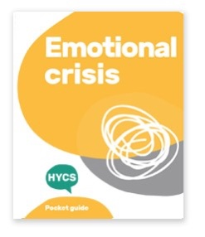
Support outside of the session – www.hycscounselling.co.uk
Support from your counsellor is limited to your agreed appointment time only and counsellors will not be available outside of session times or able to pick up messages. However, you can contact HYCS’ office if you need to get a message to your counsellor about the appointment or if you have any queries.
At other times you can get practical help via the Self Help Hub on our HYCS website www.hycscounselling.co.uk/self-help-hub/ which has many ideas to help you
support yourself in between sessions.
If you are in crisis and need immediate help see the
HYCS’ Emotional Crisis pocket guide with details of crisis services
including 24/7 support options such as Childline. Download your free copy at
www.hycscounselling.co.uk/self-help-hub/emotional-crisis/.

Got any questions?
If you are unsure about or would like to discuss anything included in this guide about our telephone and online (video) counselling support services, please contact us - we will be pleased to help!
Contact HYCS by tel. 020 8568 1818, text 07784 481308 or email ask@hycscounselling.co.uk.

