
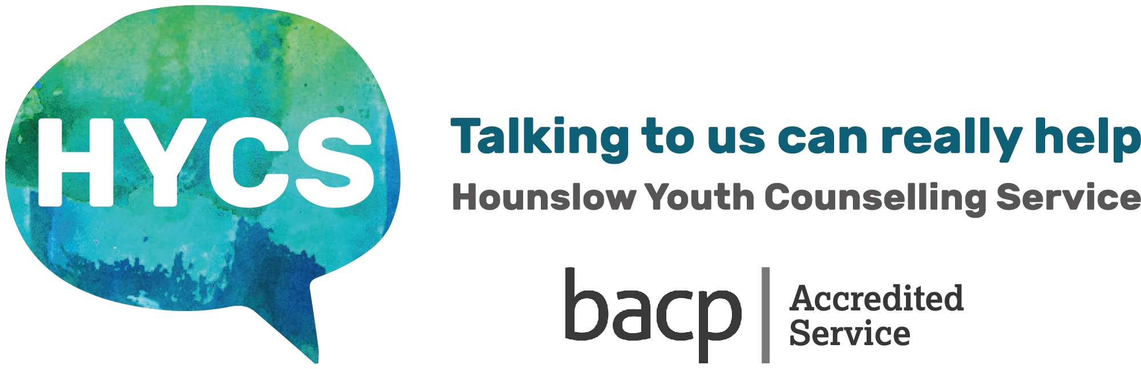
Hounslow Youth Counselling Service
ONLINE
78 St Johns Road, Isleworth, Middlesex, TW7 6RU
Tel: 020 8568 1818 www.hycscounselling.co.uk
Many thanks for completing! Please return to HYCS. 2024-2025

FEEDBACK FORM – please tell us what you think!

Age:
Gender:
Male Female
Non-Binary Trans
Other …………………..
Prefer not to say
How would you describe
your ethnic background?
Asian Bangladeshi White British
Asian Indian White European
Asian Pakistani White Irish
Black African White Other
Black Caribbean Unspecified
Chinese Mixed Heritage

How did you hear
about the service?
Leaflets
Internet
Friend
School
Parents
GP/CAMHS
Other, Please State:
Type of counselling you received (tick all that apply)
Face to face Online (video) Telephone
Please tell us how you are feeling now: (Tick one option - please add any additional comments):
Much Improved Some improvement No change Less able to cope Much less able to cope

Would you recommend the service to others? (Tick one option – please add any additional comments.
Yes Undecided No
What would you say about the counselling you received? Did you gain what you hoped to achieve?

How would you rate your experience with HYCS?
(tick one option)
Very helpful
Helpful
Neither helpful or unhelpful
Unhelpful
Very unhelpful
If helpful or very helpful, please tick in what way?
(tick all that apply)
Increased sense of well-being Better relationships
Increased Self esteem Increased confidence
Better ways of coping Improved problem solving
Other – please specify:

Do you consent to this information being anonymously used in our HYCS website, literature and reports? Yes No
Have you used any HYCS information leaflets or areas on HYCS website? Which have you found helpful?
Intro Booklet Anxiety Sleep Exam Stress Emotional Crisis Gender ID/Sexuality
Calm Breathing Eat Well Adrenalin Alert/Relax Rest & Digest Guide to HYCS online/tel counselling
HYCS website – A-Z Directory HYCS website – Self Care Kit HYCS website – App Zone Not used
How did you hear
about the service?
Leaflets
Internet
Friend
School
Parents
GP/CAMHS
Other, Please State:
How many sessions have you attended?

